**DON BOSCO COLLEGE OF ENGINEERING**

**FATORDA, MARGAO, GOA – 403 602.**

**DEPARTMENT OF COMPUTER ENGINEERING**

**2023 – 2024**



**“Doctor Appointment Booking System”**

**By**

**Mr. Malcolm Antao**

**Ms. Nathania Baptista**

**Ms. Anushka Da Silva**

Under the Guidance of

**Prof. Amey Tilve**

**Assistant Professor**

**BACHELOR OF ENGINEERING: GOA UNIVERSITY**

**DON BOSCO COLLEGE OF ENGINEERING**

**FATORDA, MARGAO, GOA- 403602.**

**2023 – 2024**

**CERTIFICATE**

This

**Mini-Project Report ‘Doctor Appointment Booking System’**

Submitted in partial fulfillment of the requirements for Bachelor’s Degree in Computer Engineering of Goa University is the bonafide work of

**Ms. Anushka Da Silva (2214005)**

**Mr. Malcolm Antao (2214025)**

**Ms. Nathania Baptista (2214032)**

**____________**

**Prof. Amey Tilve**

**Assistant Professor**

**PROJECT GUIDE**

**_____________**

**Dr. Gaurang S Patkar**

**HEAD OF DEPARTMENT**

**DON BOSCO COLLEGE OF ENGINEERING**

**FATORDA, MARGAO, GOA- 403 602.**

**2023 – 2024**

**CERTIFICATE**

**Project Report**

**Submitted by**

**Ms. Anushka Da Silva (2214005)**

**Mr. Malcolm Antao (2214025)**

**Ms. Nathania Baptista (2214032)**

**In partial fulfillment of the requirements of the Bachelor’s Degree in Computer Engineering of Goa University is evaluated and found satisfactory.**

**DATE: _____________ EXAMINER 1: _______________**

**PLACE: _____________ EXAMINER 2: _______________**

**ABSTRACT**

***The Doctor Appointment Booking System revolutionizes healthcare by enabling patients to conveniently schedule appointments online based on their doctor’s availability. Patients can easily select preferred time slots and receive automated reminders. For doctors, this system offers real-time schedule management thus improving clinic efficiency. Overall, this Doctor Appointment Booking System enhances patient-doctor interaction, optimizes clinic workflows and boosts healthcare accessibility and satisfaction.***

**ACKNOWLEDGEMENT**

We would like to take this opportunity to express our sincere and heartfelt gratitude to all the stakeholders who have helped us directly or indirectly by providing us with the opportunity, the necessary expertise and guidance, motivating and mentoring us constantly. Without their valuable help this project would have always remained as a dream.

We would like to thank our Director **Rev. Fr. Kinley D’Cruz** and our principal **Dr. Neena S. P. Panandikar** for providing us with the necessary facilities and the much-needed motivation throughout the project. We are indebted to you.

We would like to express our gratitude to our Head of the Department, **Dr. Gaurang Patkar** for showing confidence in us and for giving us timely suggestions and advice with his rich experience and expertise.

Guides are like beacons of light showing us the right path in the phase of uncertainty and confusion during the course of the project. When things seem to be drifting away from the goal, they put us back on the track with their constant monitoring and guidance and expertise. We are indebted to our Internal Guide **Prof.** **Amey Tilve** Professor, Department of Computer Engineering.

**TABLE OF CONTENTS**

|  |  |  |
| --- | --- | --- |
| Chapter no. | Contents | Page no. |
|  | TITLE PAGE | 1 |
|  | CERTIFICATE PAGE I | 2 |
|  | CERTIFICATE PAGE II | 3 |
|  | ABSTRACT | 4 |
|  | ACKNOWLEDGEMENT | 5 |
|  | TABLE OF CONTENTS | 6 |
|  |  |  |
| **CHAPTER 1** | **INTRODUCTION** | 9 |
|  | 1.1 Introduction Of The Project | 9 |
|  | 1.2 Purpose Of The Project | 10 |
|  | 1.3 Problem Definition | 11 |
|  | 1.3.1 Existing System | 12 |
|  | 1.3.2 Proposed System | 13 |
|  | 1.4 Scope of Project | 14 |
|  | 1.5 Report Organization | 14 |
|  |  |  |
| **CHAPTER 2** | **SOFTWARE REQUIREMENT SPECIFICATION (SRS)** | 15 |
|  | 2.1 Introduction | 15 |
|  | 2.1.1 Purpose | 15 |
|  | 2.1.2 Scope | 16 |
|  | 2.2 Technologies | 16 |
|  | 2.3 Overall Description | 17 |
|  | 2.3.1 Product Perspective | 17 |
|  |  |  |
| **CHAPTER 3** | **DESIGN** | 18 |
|  | 3.1 Introduction | 18 |
|  | 3.1.1 Scope and Purpose | 18 |
|  | 3.1.2 Overall System Design Objectives | 18 |
|  | 3.1.3 Structure of Design Document | 19 |
|  | 3.2 Data Design | 19 |
|  | 3.2.1 Entity Relationship Diagram | 19 |
|  | 3.3 Functional Design Description | 20 |
|  | 3.3.1 Data Flow Diagrams | 20 |
|  | 3.3.1.1 Context Level Diagram | 20 |
|  | 3.3.1.2 Level 0 Diagram | 20 |
|  | 3.3.1.3 Level 1 Diagram | 21 |
|  | 3.3.2 Use Case Diagram | 22 |
|  | 3.3.3 Sequence Diagram | 22 |
|  |  |  |
| **CHAPTER 4** | **IMPLEMENTATION** | 23 |
|  | 4.1 Introduction | 23 |
|  | 4.2 Frontend Development | 23 |
|  | 4.3 Backend Development | 24 |
|  | 4.4 Framework | 24 |
|  | 4.5 Database Management | 24 |
|  | 4.6 User Roles and Permissions | 24 |
|  | 4.6.1 Doctor | 24 |
|  | 4.6.2 Patient | 25 |
|  | 4.7 Security Measures | 25 |
|  | 4.8 Performance Considerations | 25 |
|  | 4.9 User Interface Design | 26 |
|  | 4.9.1 Landing Page | 26 |
|  | 4.9.2 Patient Sign-Up/ Login Page | 28 |
|  | 4.9.3 Doctor Login Page | 29 |
|  | 4.9.4 Patient Dashboard | 30 |
|  | 4.9.5 Patient Profile | 31 |
|  | 4.9.6 Doctor Dashboard | 32 |
|  | 4.9.7 Doctor Profile | 32 |
|  | 4.9.8 Doctor Scheduling | 33 |
|  |  |  |
| **CHAPTER 5** | **TEST CASES** | 34 |
|  |  |  |
| **CHAPTER 6** | **CONCLUSION** | 41 |
|  | REFERENCES | 42 |

**CHAPTER 1**

**INTRODUCTION**

**1.1 INTRODUCTION OF THE PROJECT**

In today’s rapidly evolving healthcare environment, the integration of technology has become increasingly vital in reshaping the dynamics of patient-doctor interactions. The Doctor Appointment Booking System aims to revolutionize the conventional approach to scheduling medical consultations. With a keen awareness of the growing need for efficiency and accessibility in healthcare services, the system represents a shift in how patients engage with their healthcare providers.

At its core, the Doctor Appointment Booking System is a digital platform designed to simplify and streamline the appointment booking process. It empowers the patient to take control of their healthcare journey by providing them with the ability to schedule appointments at their convenience. Through an intuitive and user-friendly interface, individuals can browse through available time slots based on the availability of their doctor thus eliminating the need for phone calls or in-person visits. This seamless integration of technology not only enhances the overall patient experience but also contributes to greater efficiency in clinic operations.

The Doctor Appointment Booking System enables patients to make informed decisions about their healthcare needs as well as informs the patient and the doctor about the upcoming scheduled appointments ensuring that the patient is always up to date with check-ups and follow-ups.

As we embark on this journey, our vision for the project extends beyond mere appointment scheduling. We envision a platform that serves as a catalyst for positive change within the healthcare ecosystem, promoting collaboration between patients and healthcare providers, enhancing accessibility to care, ultimately improving health outcomes. The Doctor Appointment Booking System aims to redefine the standards of healthcare delivery, paving the way for a brighter and more inclusive future for everyone involved.

**1.2 PURPOSE OF THE PROJECT**

The purpose of creating the Doctor Appointment Booking System project is as follows:

1. **Enhancing Accessibility**: The primary purpose of the project is to make healthcare services more accessible to patients by providing them with a convenient and user-friendly platform to schedule appointments with their doctors.
2. **Streamlining Appointment Scheduling**: Our project aims to streamline the appointment scheduling for both patient and healthcare providers, reducing the time and effort required to book appointments through traditional methods such as phone calls or in-person visits.
3. **Improving Efficiency:** By digitizing the appointment booking process, the project improves the efficiency of clinic operations by automating tasks such as appointment reminders, updating doctor availability and reducing the likelihood of scheduling conflicts.
4. **Empowering Patients**: To empower patients by giving them greater control over their healthcare journey. Patients can choose appointment times that best fit their schedules, access relevant information about their appointments, and make informed decisions about their healthcare needs.
5. **Facilitating Communication**: The project facilitates transparent communication between patients and healthcare providers by providing a centralized platform for appointment scheduling. This fosters better patient-doctor interaction and enables healthcare providers to better understand and address patient needs.
6. **Providing Efficiency in Healthcare Delivery**: Ultimately, the Doctor Appointment Booking System aims to contribute to the overall efficiency and effectiveness of healthcare delivery by optimizing clinic workflows, reducing administrative burdens and improving patient satisfaction.

**1.3 PROBLEM DEFINITION**

The problem definition of the Doctor Appointment Booking System project revolves around the inefficiencies and limitations inherent in traditional methods of scheduling medical appointments. These include:

1. **Inconvenience**: Patients often face challenges in scheduling appointments through traditional methods such as phone calls or in-person visits, leading to delays and frustration.
2. **Time-consuming Processes**: The manual nature of appointment scheduling can be time-consuming for both patients and healthcare providers, resulting in inefficiencies and potential scheduling conflicts.
3. **Limited Access**: Patients may encounter difficulties in accessing healthcare services due to limited availability of appointment slots or difficulties in reaching healthcare providers during office hours.
4. **Communication Barriers**: Lack of transparent communication between patients and healthcare providers can lead to misunderstandings, missed appointments and suboptimal patient care.

In summary, the problem definition of the Project lies in addressing these challenges to create a more efficient and accessible system for scheduling medical appointments, thereby enhancing the overall patient experience and optimizing clinic workflows.

**1.3.1 EXISTING SYSTEM**

1. **Phone-Based Booking**: Patients typically call the clinic to schedule appointments with their doctors. Clinic staff manually check the doctor’s availability and book the appointment accordingly. This method is prone to errors, long wait times and may not be convenient for patients who cannot make phone calls during office hours.
2. **In-Person Appointment Scheduling**: Some clinics allow patients to schedule appointments in person by visiting the reception desk. While this method offers face-to-face interaction, it requires patients to travel to the clinic, leading to potential time constraints and inconvenience.
3. **Manual Appointment Books**: Many clinics still rely on paper-based appointment books or electronic spreadsheets to manage appointments. This method can be prone to errors, such as double bookings or misplaced records and lacks real-time updating capabilities.
4. **Limited Online Bookings**: Some healthcare providers offer limited online appointment booking options through their websites or third-party platforms. However, these systems may not be user-friendly, may lack real-time availability updates and often require patients to fill out lengthy forms.

Overall, the existing system for scheduling medical appointments is often fragmented, inefficient and may not fully meet the needs of patients and healthcare providers in terms of convenience, accessibility and efficiency. This highlights the need for a more streamlined and user-friendly solution like the Doctor Appointment Booking System to address these limitations and improve the appointment scheduling process for everyone involved.

**1.3.2 PROPOSED SYSTEM**

The Proposed Project offers a streamline, secure and user-friendly solution for scheduling medical appointments, benefiting both patient and healthcare providers.

1. **Online appointment Booking**: Patients can see up-to-date appointments with doctors conveniently through a user-friendly online interface.
2. **Real-time Availability Reminders**: Patients can see up-to-date appointment slots, reducing scheduling conflicts.
3. **Automated Appointment Reminders**: The system sends reminders to patients and the doctor about upcoming appointments.
4. **Prescription Management**: The doctor has the ability to enter the patient’s prescription which can then be viewed by the patient once logged in.
5. **Patient Information Management**: Patients can provide the information about their weight, height and other basic information aiding the doctor in preparation.
6. **Doctor Scheduling Management**: doctors can update availability and manage schedules efficiently.
7. **Enhanced Patient Experience**: The system aims to improve convenience, accessibility and satisfaction in healthcare delivery.

**1.4 SCOPE OF THE PROJECT**

This project aims to significantly enhance the convenience and efficiency of healthcare services for both patients and healthcare providers. By offering seamless appointment scheduling, availability and prescription updates as well as automated reminders. The system empowers patients to manage their health care needs with ease. Additionally, features such as doctor schedule management and patient information handling streamline clinic workflows, leading to improved productivity and patient satisfaction. Ultimately, the Doctor Appointment Booking System revolutionizes the patient-doctor interaction making access to healthcare services more accessible, convenient and user-friendly.

**1.5 REPORT ORGANIZATION**

This report contains a total of 6 Chapters which are organized as follows:

1. Chapter 1: Discusses the basic information of the website and other similar details.
2. Chapter2: It will discuss the Project’s Software Requirements Specification, which includes most of the important and crucial data and the necessary equipment that will be required for the development of the project.
3. Chapter 3: Addresses the project design, in which we learn what kind of modules we are implementing in our project and the many diagrams which will help in deciding the flow of data to and from different elements.
4. Chapter 4: Focuses mainly on the implementation, which essentially shows the overall flow of the project.
5. Chapter 5: The final verdict/conclusion is mentioned in Chapter 5.
6. Chapter 6: The possible test cases are discussed in Chapter 6 along with the details of the steps, data and prerequisites necessary to verify each feature.

**CHAPTER 2**

**SOFTWARE REQUIREMENT SPECIFICATION (SRS)**

**2.1 INTRODUCTION**

**2.1.1 PURPOSE**

This document outlines the purpose and capabilities of the Doctor Appointment Booking System project, highlighting its potential to enhance the healthcare experience for both patient and health care providers. By offering a user-friendly platform for seamless appointment scheduling, real-time availability updates, patient’s prescription and automated appointment reminders. We aim to streamline clinic workflows, reduce administrative burdens and improve overall patient satisfaction. The project aims to empower users to efficiently manage their healthcare needs, making the process of booking appointments more convenient and accessible. The ultimate purpose is to revolutionize the patient-doctor interaction, optimizing healthcare and fostering better patient outcomes.

**2.1.2 SCOPE**

The scope of the project encompasses the development of an appointment booking system that enhances the efficiency and accessibility of healthcare services for both patients and healthcare providers.

1. **User Authentication module**: This module handles user registration and login functionalities. Users including patients and doctors can login, create accounts and manage their profiles.

2**. Appointment Scheduling Module**: This module allows patients to view available appointment slots and schedule appointments with the doctor. It includes the feature of selecting preferred date and time.

3**. Appointment Reminder Module**: This module sends automated reminders to patients prior to their scheduled appointments.

4. **Doctor Schedule Management Module**: This module allows healthcare providers to manage their schedules and availability. Doctors can update their availability as needed.

5**. Patient Profile Module**: This profile handles the storage and management of patient information and includes features such as storing patient name, age, contact information etc.

6. **Doctor Profile Module**: This profile handles the storage and management of doctor information and includes features such as storing doctor’s name, qualification, contact information etc.

7. **Prescription Module**: This module is responsible for storing the prescription as prescribed by the doctor.

**2.2 TECHNOLOGIES:**

* HTML
* CSS
* JAVASCRIPT
* PHP
* MYSQL
* PHP

**2.3 OVERALL DESCRIPTION**

**2.3.1 PRODUCT PERSPECTIVE:**

From a product perspective, this project focuses on delivering a user-centric online platform that facilitates seamless interaction between patients and healthcare providers. It prioritizes user experience by designing an intuitive interface for both patient and doctor, thus ensuring ease of use and satisfaction. With a feature-rich environment, patients can easily book appointments, view their prescriptions and receive reminders of upcoming appointments while doctors can efficiently manage their schedules, view upcoming appointments and enter their patient’s prescription details. Leveraging modern technologies and development frameworks, the platform ensures reliability and performance. Plus, we are always listening to feedback and making improvements to make sure it’s the best it can be. Ultimately, this project aims to deliver not just a product, but a dynamic solution that enhances the healthcare experiences for everyone involved, delivering measurable value and fostering positive outcomes.

**CHAPTER 3**

**DESIGN**

**3.1 INTRODUCTION**

**3.1.1 SCOPE AND PURPOSE**

The purpose of the design phase is to develop a clear understanding of how the doctor appointment booking system will fulfill the goal of providing a seamless and efficient appointment scheduling experience for patients and doctors. As the developer works on the project, the test for every design decision should be 'Does this feature contribute to making appointment booking easier and more convenient for users?' A purpose statement affects the design process by explaining how the system will achieve its primary objective of simplifying the appointment booking process. The Design Document will verify that the current design meets all explicit requirements, such as user interface specifications, scheduling algorithms, and data management, as well as implicit requirements desired by patients and doctors, such as ease of use, reliability, and accessibility.

**3.1.2 OVERALL SYSTEM DESIGN OBJECTIVES**

The overall system design objectives for the doctor appointment booking system aim to create an efficient, user-friendly platform that ensures reliable scheduling for patients and doctors, offering a streamlined, secure, and intuitive solution. This includes designing interfaces that allow patients to conveniently view up-to-date appointments with doctors and implementing real-time availability reminders to help avoid scheduling conflicts. Automated appointment reminders and patient information management further enhance the system's usability, aiding doctors in preparation and improving patient experience. Doctor scheduling management ensures efficient availability updates and schedule management. Additionally, the system should scale easily, accommodate various appointment types and scheduling preferences, and comply with relevant regulations while optimizing performance and securely managing data. These objectives ensure the system meets the needs of users while adhering to industry standards.

**3.1.3 STRUCTURE OF DESIGN DOCUMENT**

* Data Design-The data Design includes an ERD as well as Database design.
* Functional Design Description - This section has the functional partitioning from the SRS, and goes into great detail to describe each function. It includes the Context Level, Level 0 and Level 1 Data Flow Diagrams, Use Case Diagram and Sequence Diagram.

**3.2 DATA DESIGN**

**3.2.1 ENTITY RELATIONSHIP DIAGRAM**

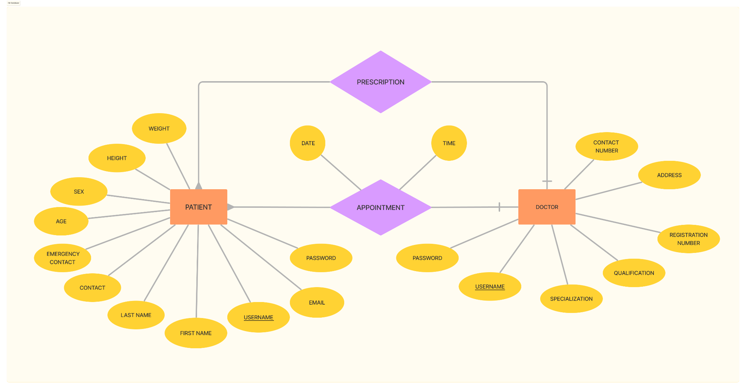

**3.3 FUNCTIONAL DESIGN DESCRIPTION**

**3.3.1 DATA FLOW DIAGRAMS**

**3.3.1.1 CONTEXT LEVEL DIAGRAM**

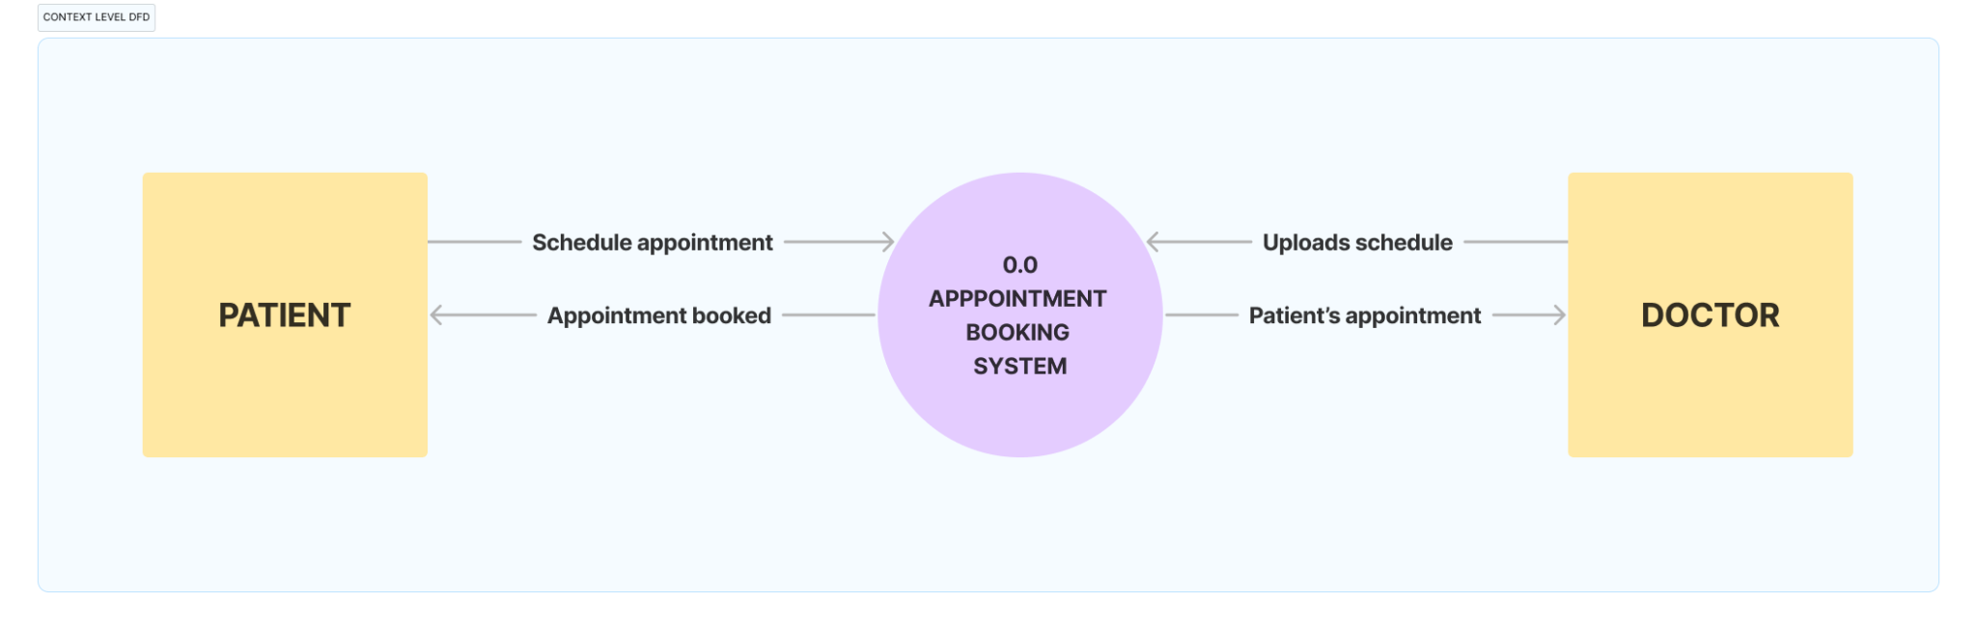

**3.3.1.2 LEVEL 0 DIAGRAM**

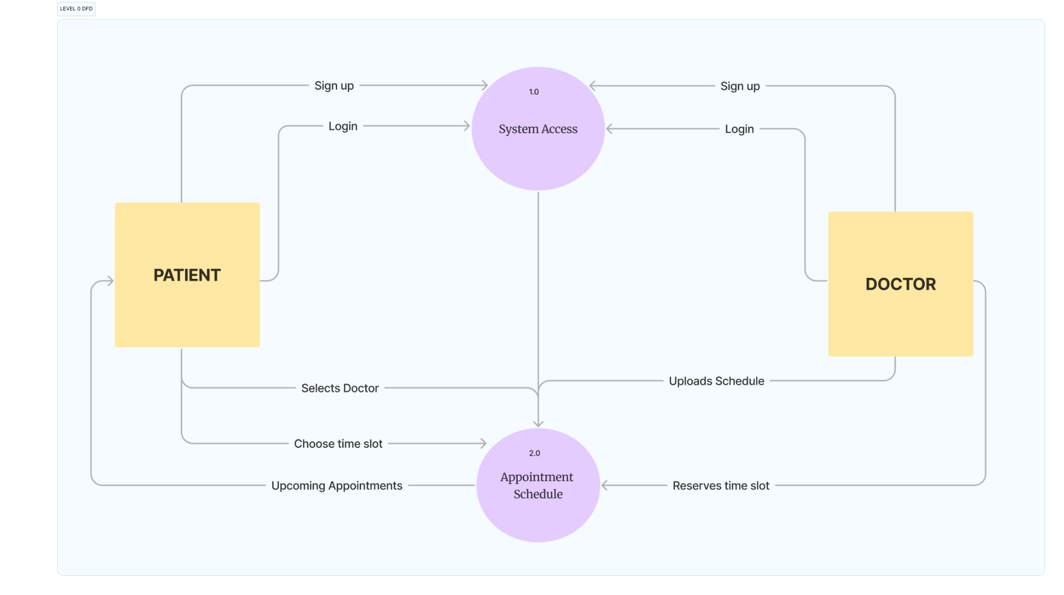

**3.3.1.3 LEVEL 1 DIAGRAM**

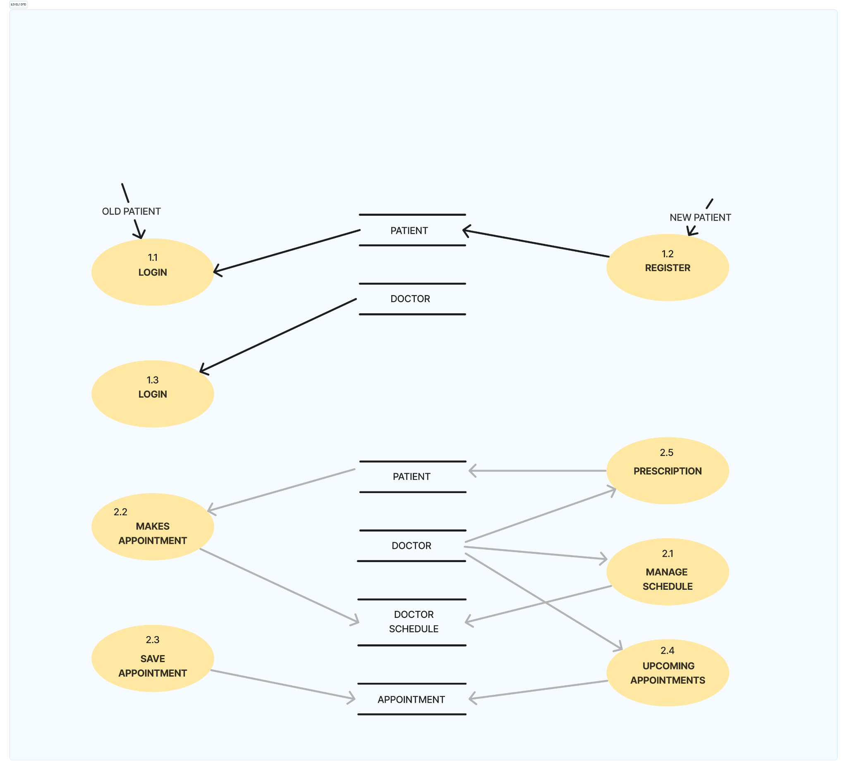

**3.3.2 USE CASE DIAGRAM**

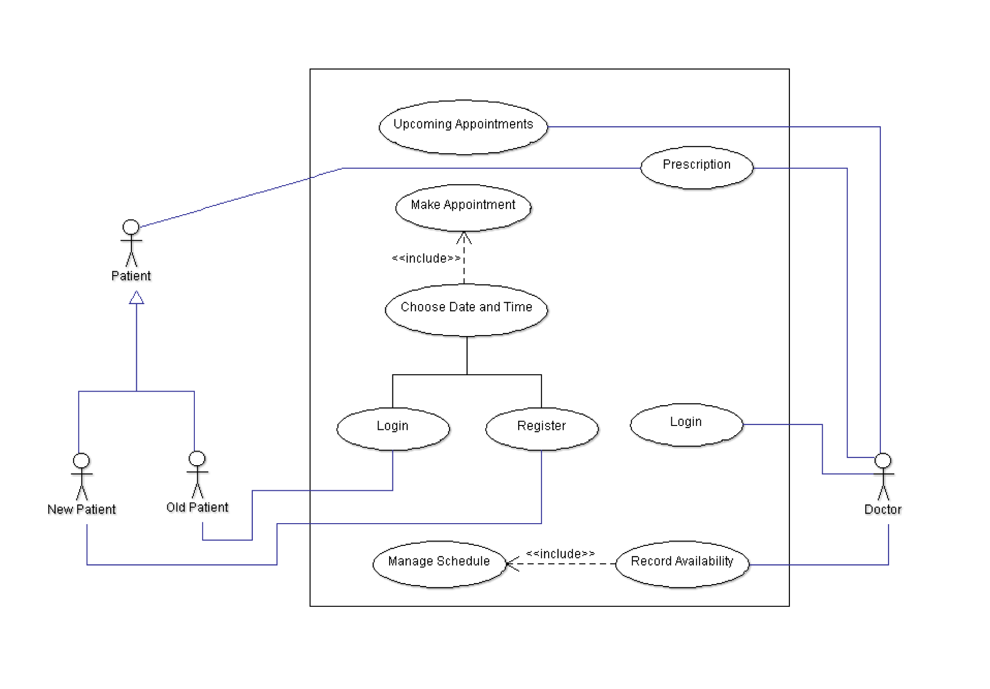

**3.3.3 SEQUENCE DIAGRAM**

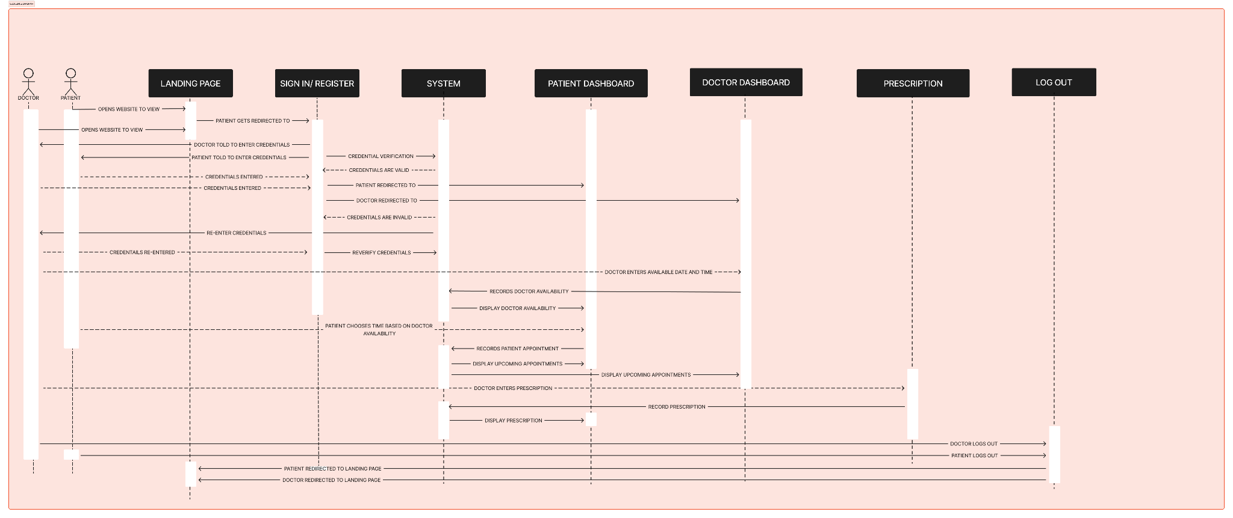

**CHAPTER 4**

**IMPLEMENTATION**

**4.1 INTRODUCTION**

The implementation phase of the doctor appointment website involves transforming conceptual designs into a functional system. Using a blend of frontend and backend technologies, our focus is on creating a seamless user experience for patients and doctors. Through careful attention to security, performance, and technical integration, we aim to deliver a robust platform that simplifies appointment scheduling and enhances healthcare accessibility.

**4.2 Frontend Development**

The frontend of the doctor appointment website will be developed using HTML 5, CSS, and JavaScript. The user interface will be designed to be intuitive and user-friendly, facilitating seamless navigation for both patients and doctors. The following features will be implemented on the frontend:

* Landing Page: Provides an overview of the website and its functionalities.
* Patient Login/Sign Up: Allows patients to authenticate or create new accounts to access their profiles and book appointments.
* Doctor Login: Provides doctors with secure access to their accounts to manage appointments and prescriptions.

**4.3 Backend Development**

The backend of the website will be implemented using PHP, providing the necessary server-side functionality to support the frontend features. PHP will handle user authentication, appointment scheduling, prescription management, and other backend processes. The following backend features will be implemented:

* Appointment Scheduling: Allows doctors to manage their availability and patients to book appointments.
* Prescribe Patient Prescription: Enables doctors to prescribe medications to patients and maintain prescription records.

**4.4 Framework**

Bootstrap will be utilized as the frontend framework to ensure a responsive and mobile-friendly design. Bootstrap's grid system and pre-styled components will streamline the development process and enhance the website's overall look and feel.

**4.5 Database Management**

MySQL will serve as the database management system for storing user data, appointment details, prescriptions, and other relevant information. Proper database normalization and indexing will be implemented to ensure efficient data retrieval and management.

**4.6 User Roles and Permissions**

**4.6.1. Doctor**

* Doctors will have access to a dedicated login portal where they can authenticate themselves.
* Upon logging in, doctors will be able to view their weekly schedule, manage appointments, and prescribe medications to patients.
* They will also have the ability to update their profile information and view the profiles of patients they have treated.

**4.6.2. Patient**

* Patients will have the option to either log in to their existing accounts or sign up for new accounts.
* Once logged in, patients can book appointments with available doctors, view their prescriptions, and update their profile details.

**4.7 Security Measures**

The website will employ basic password checking mechanisms to ensure user account security. Passwords will be hashed and securely stored in the database to prevent unauthorized access.

**4.8 Performance Considerations**

Given the nature of the website and its expected user load, no specific performance requirements are mandated. However, efforts will be made to optimize code and database queries to ensure smooth and efficient operation.

**4.9 User Interface Design**

Website screenshots will be provided to showcase the user interface design. The design will focus on clarity, ease of use, and accessibility, catering to both desktop and mobile users.

**4.9.1 Landing Page**

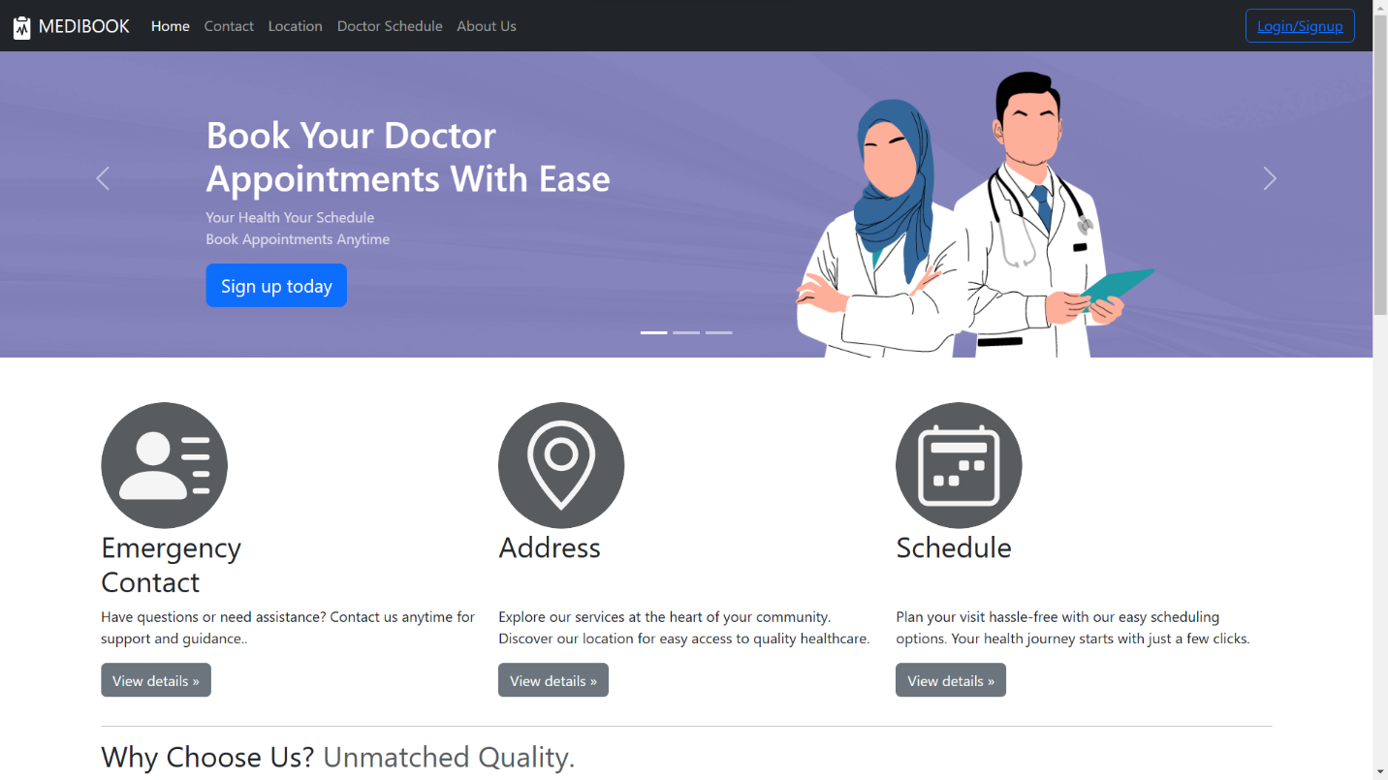

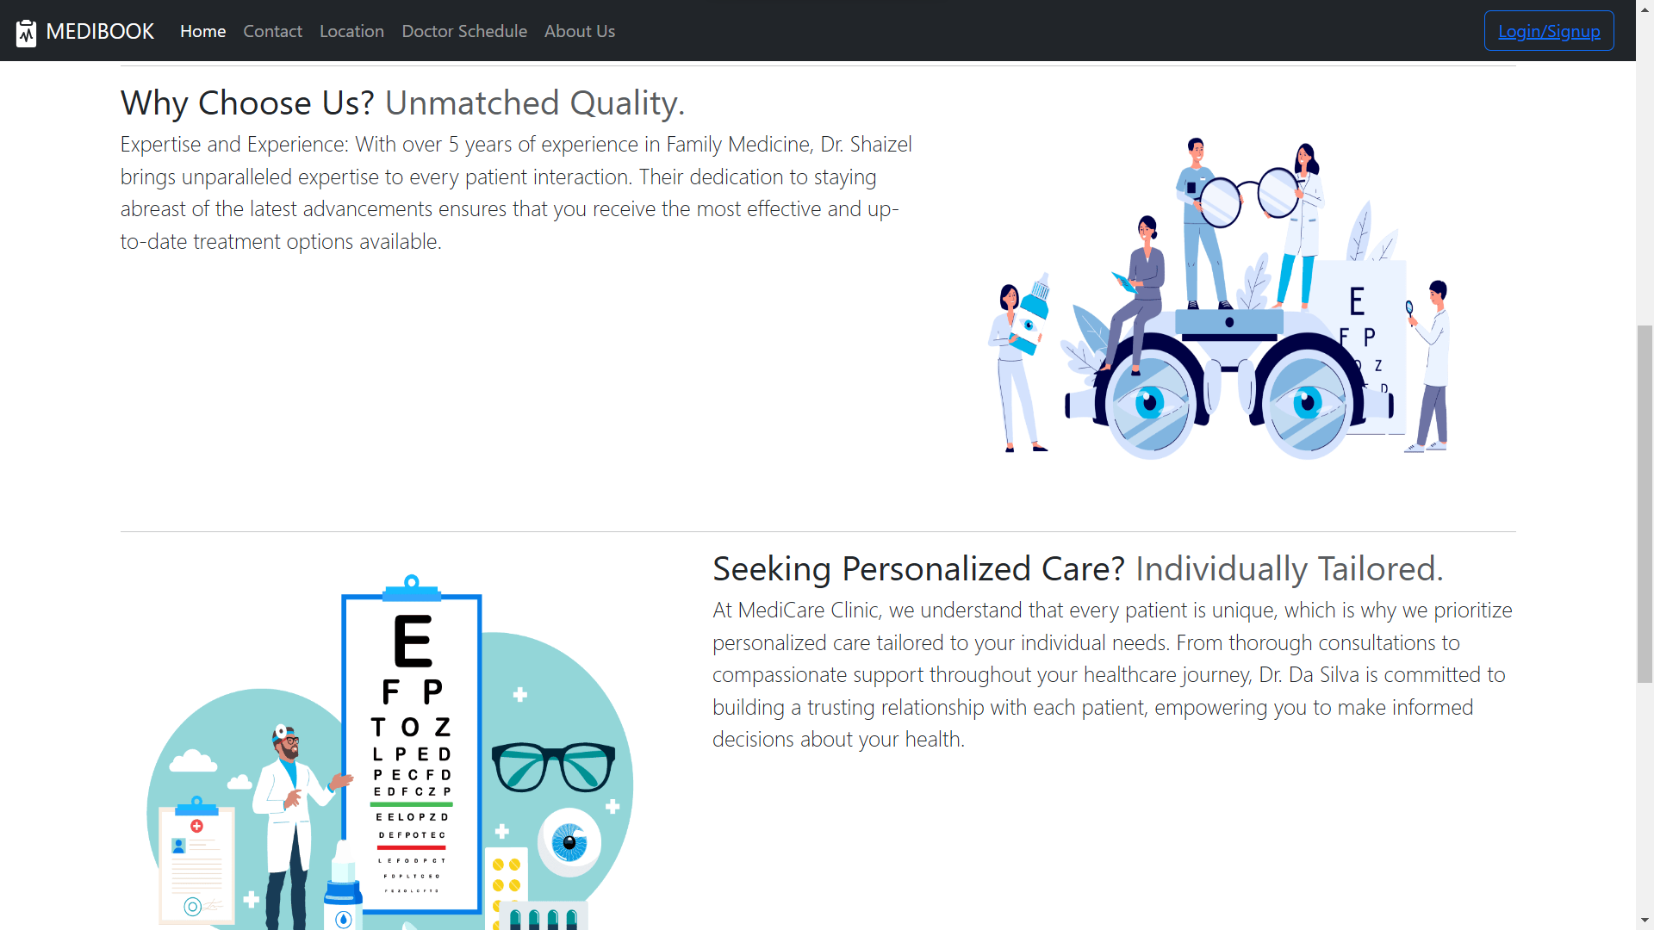

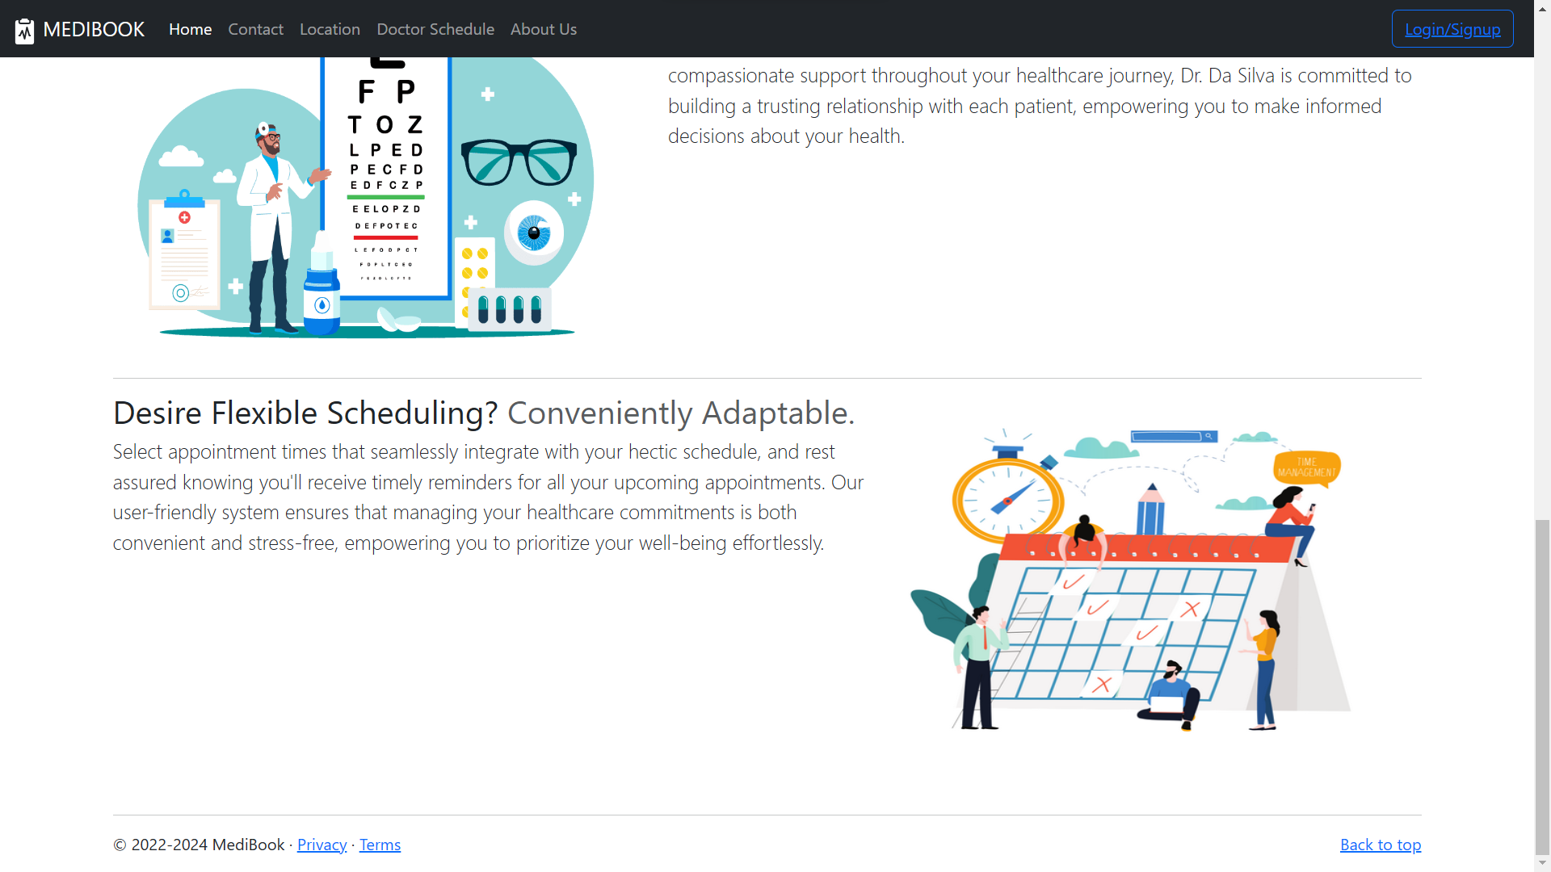

**4.9.2 Patient Sign-Up/Login Page**

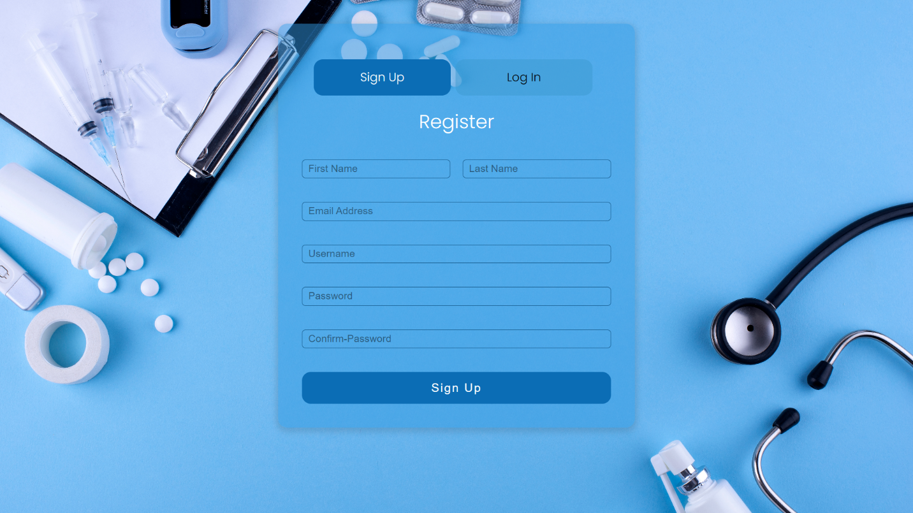

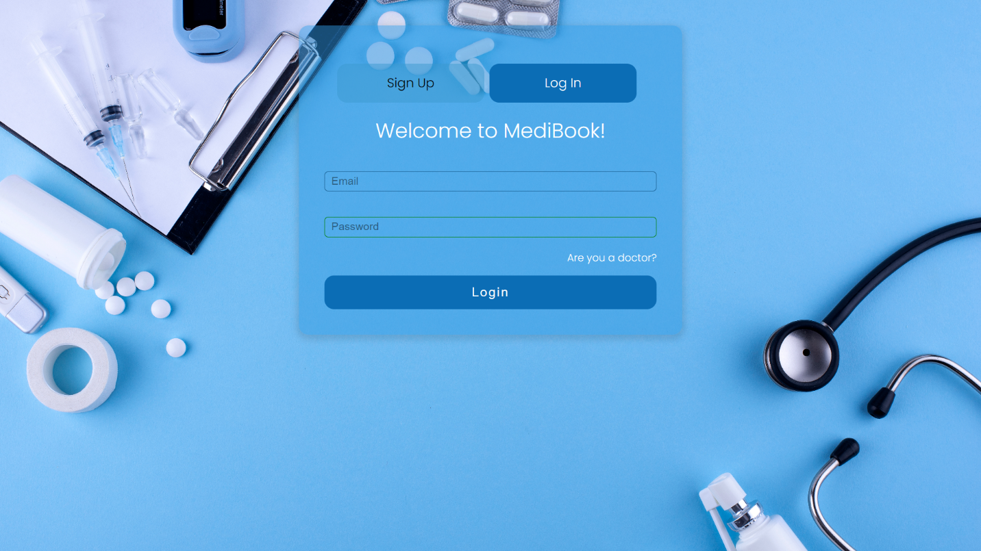

**4.9.3 Doctor Login Page**

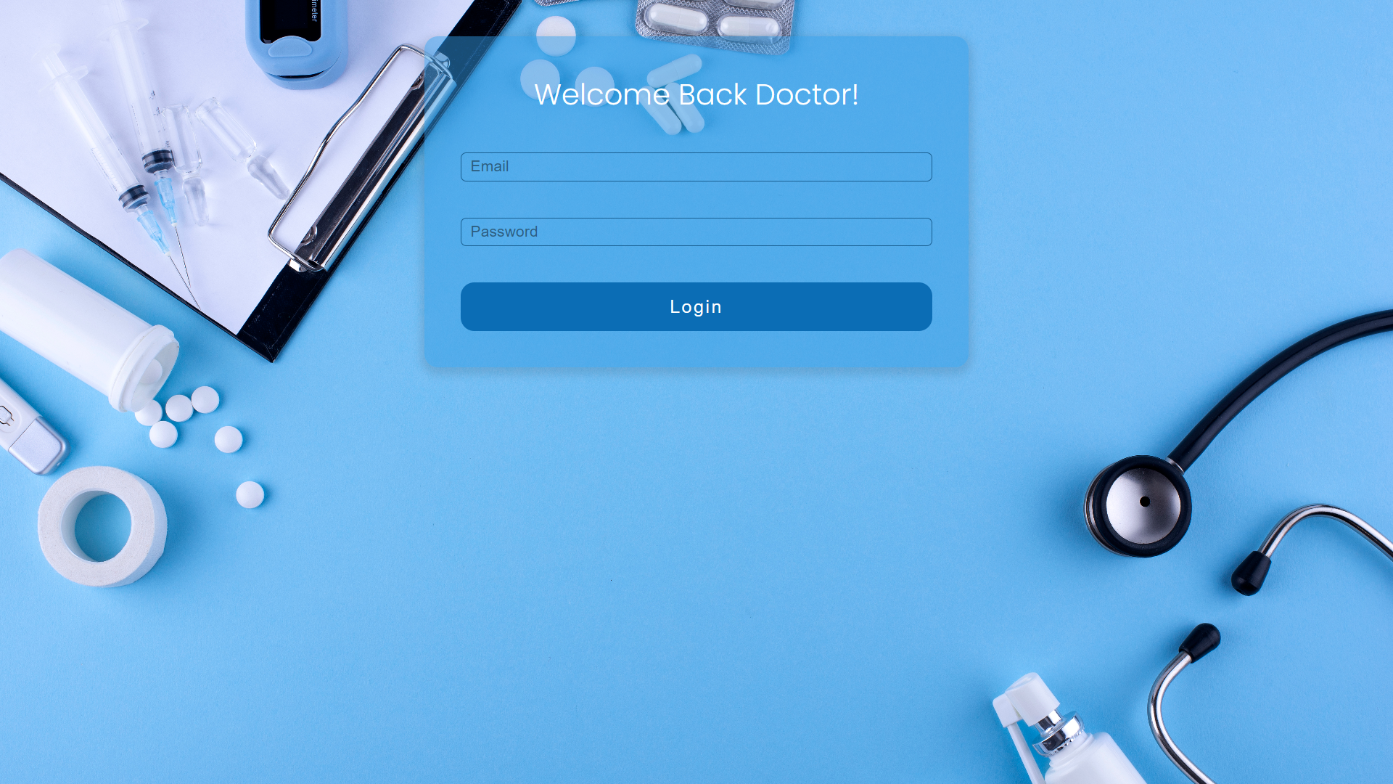

**4.9.4 Patient Dashboard**

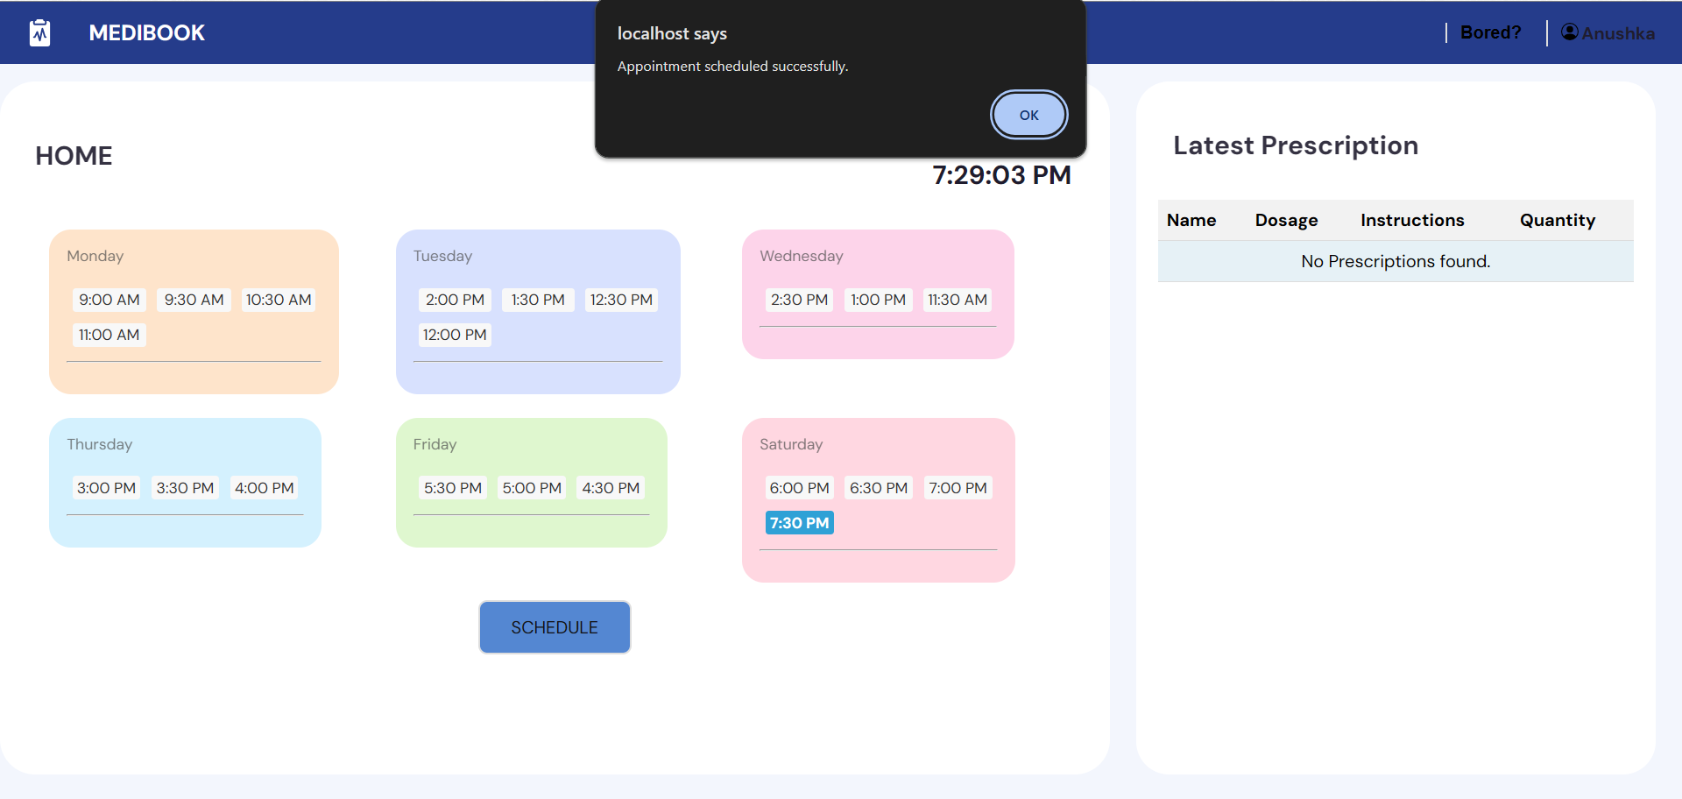

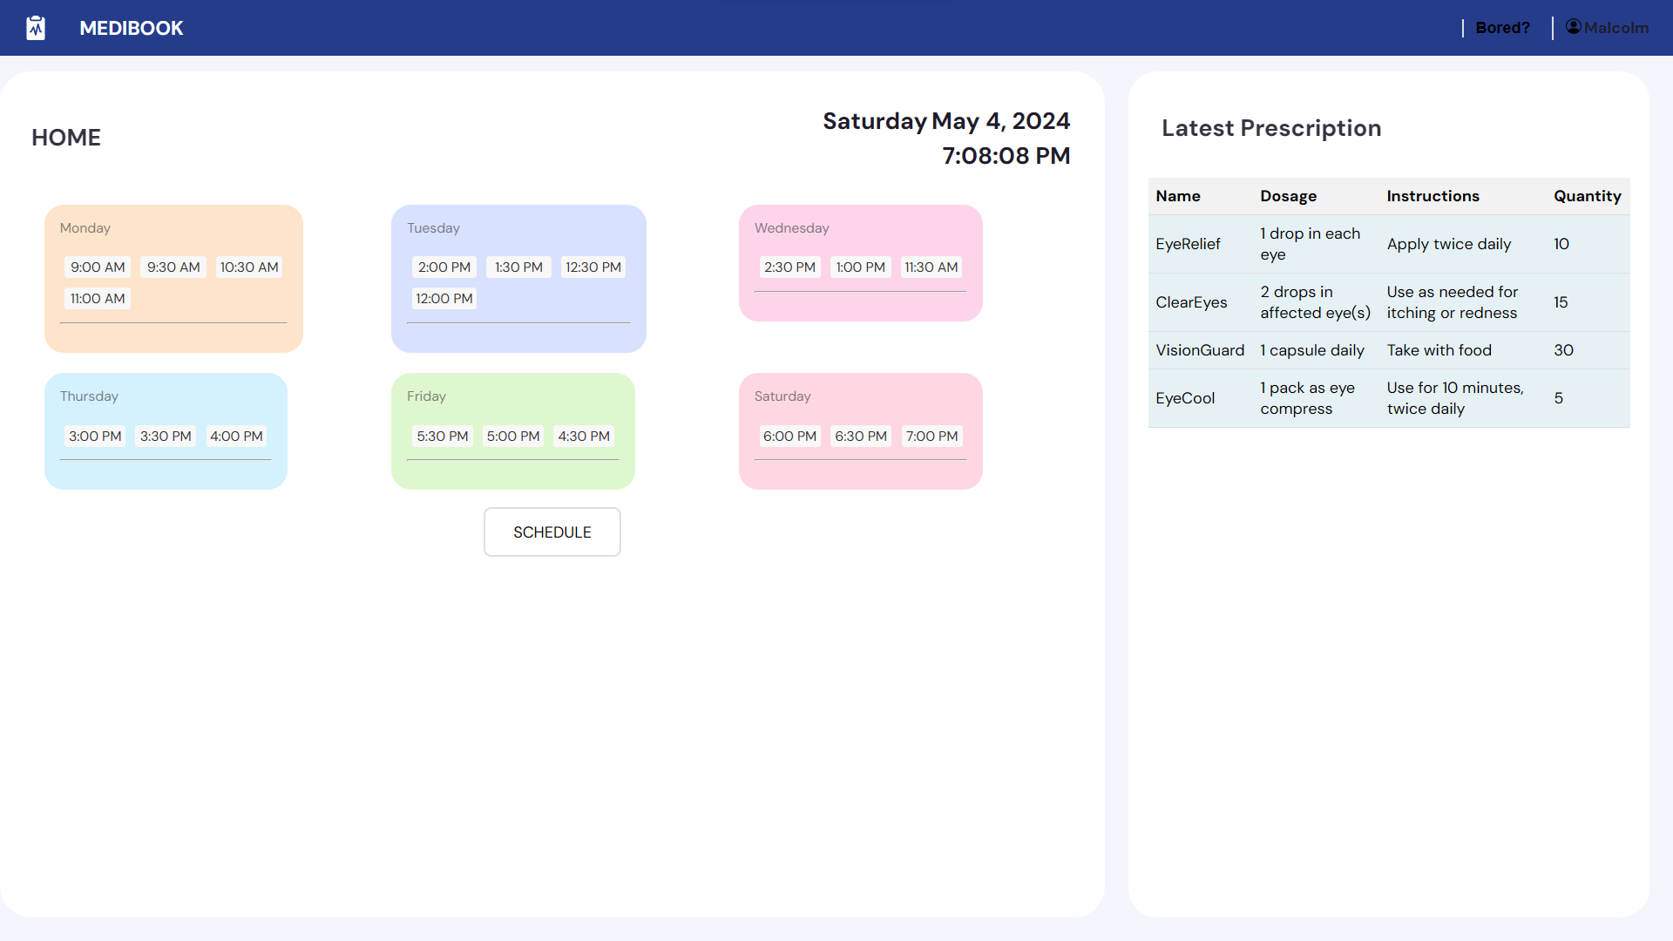

**4.9.5 Patient Profile**

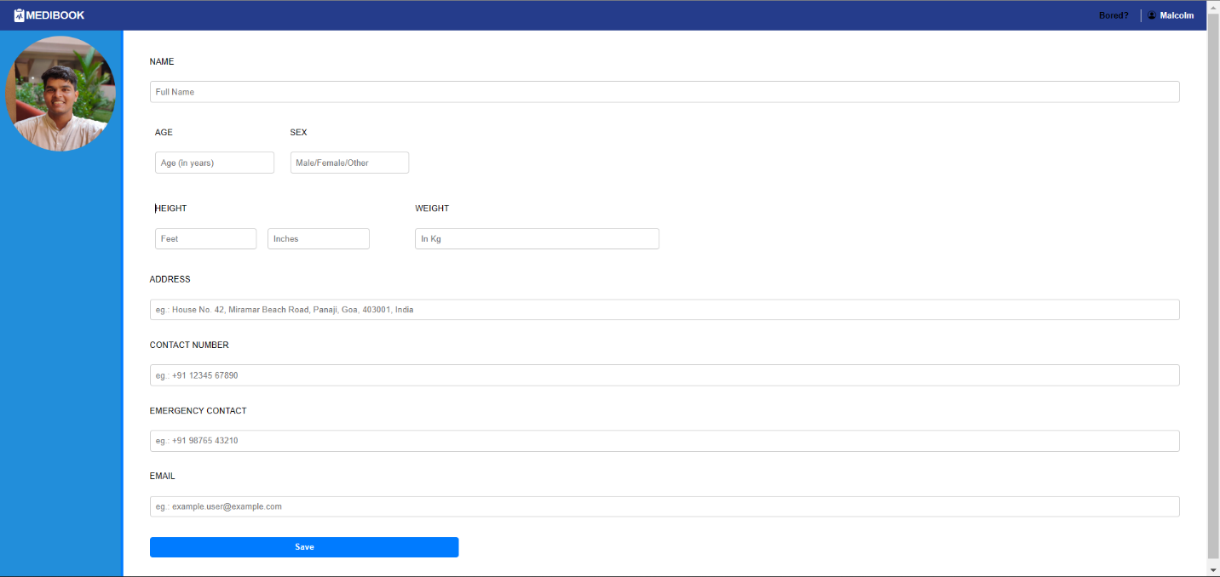

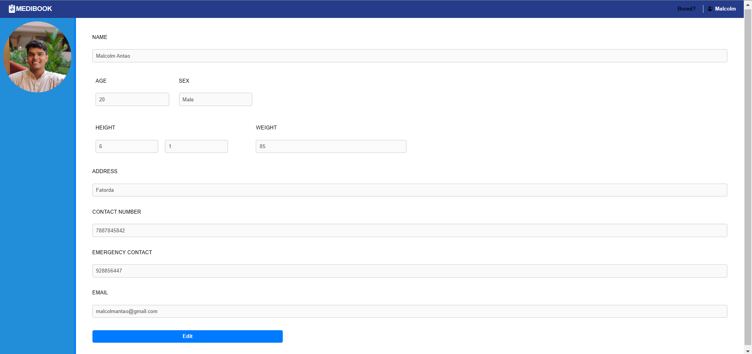

**4.9.6 Doctor Dashboard**

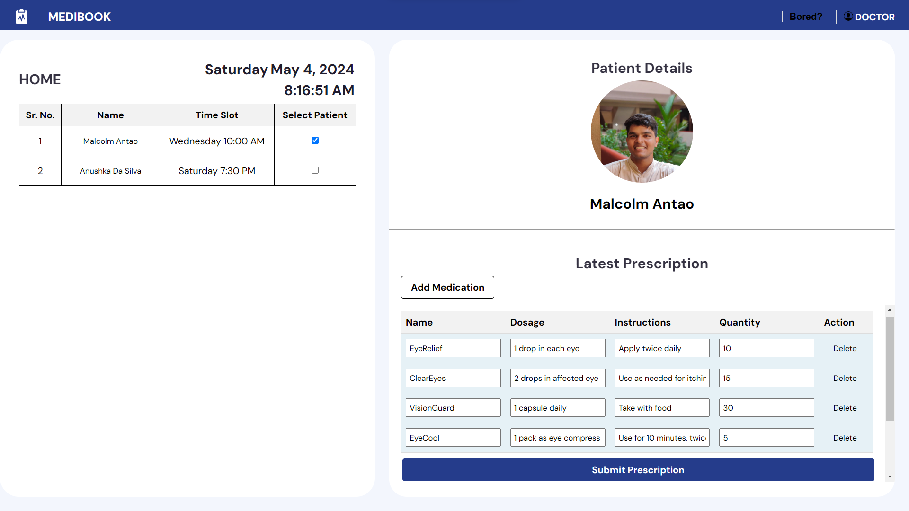

**4.9.7 Doctor Profile**

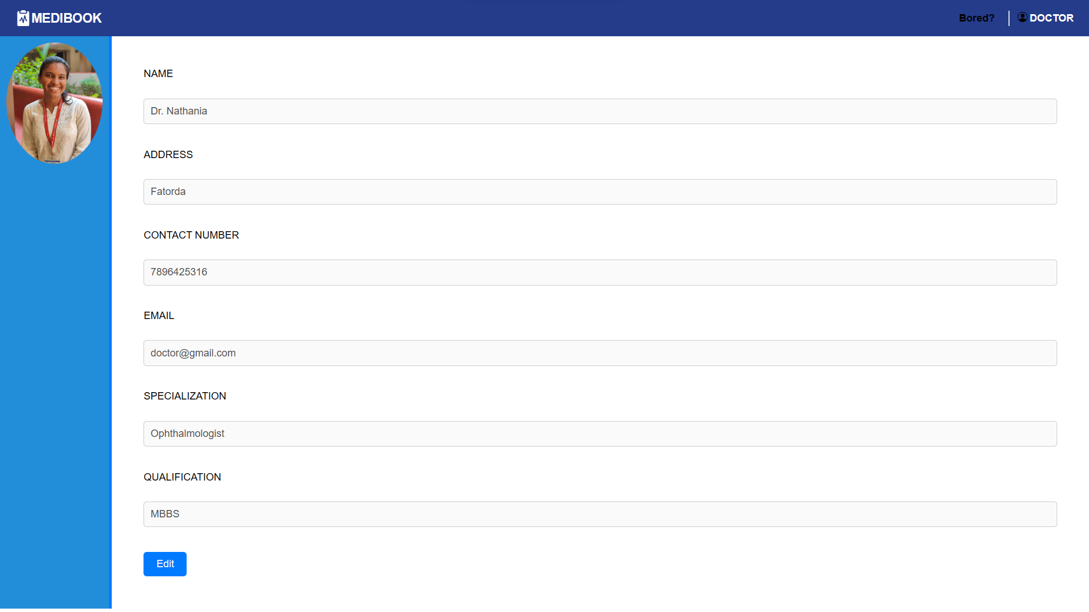

**4.9.8 Doctor Scheduling**

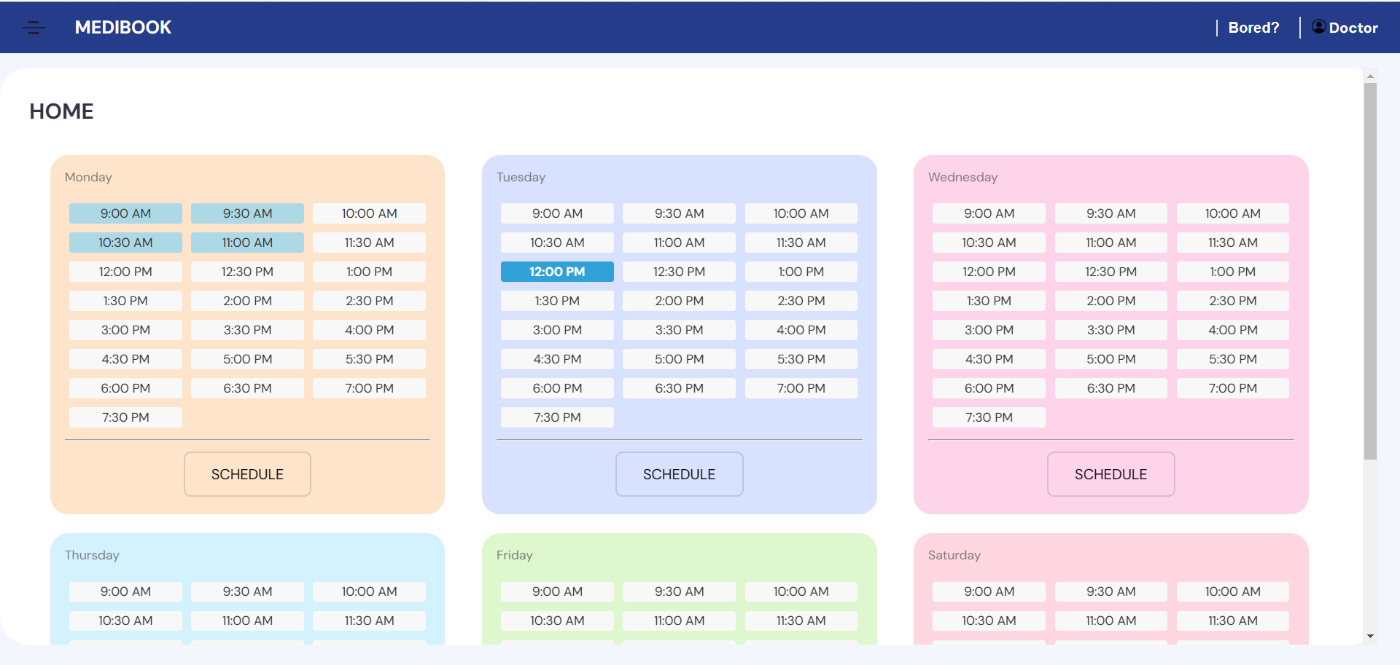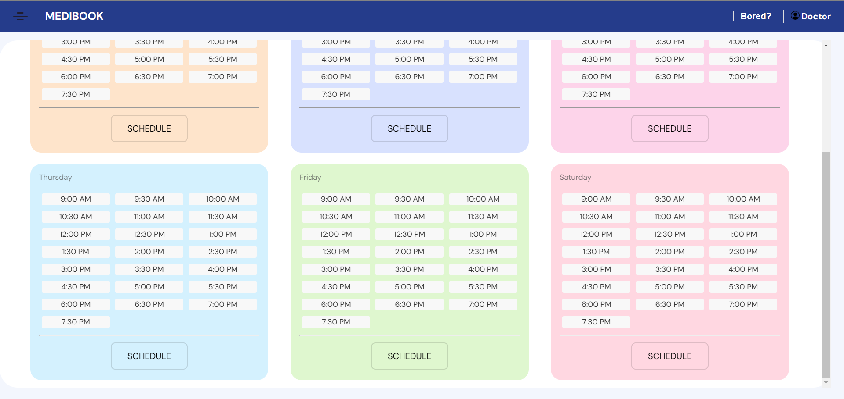

**CHAPTER 5**

**TEST CASES**

**Test Case ID: #TST001**

* **Test Scenario:** Patient Registration
* **Test Steps:**
  1. The user navigates to the registration page.
  2. The user enters valid registration details (username, name, email, password).
  3. The user clicks the 'Sign Up' button.
* **Prerequisites:** None.
* **Browser:** Chrome v86. Device: Desktop.
* **Test Data:** Valid name, username, email, and password.
* **Expected/Intended Results:** Patient account is successfully created, and the user is redirected to the login page.
* **Actual Results:** As Expected
* **Test Status:** Pass

**Test Case ID: #TST002**

* **Test Scenario:** Patient Login with Valid Credentials
* **Test Steps:**
  1. The user navigates to the login page.
  2. The user enters valid login credentials (username and password).
  3. The user clicks the 'Login' button.
* **Prerequisites:** Registered patient account with valid credentials.
* **Browser:** Chrome v86. Device: Desktop.
* **Test Data:** Valid patient username and password.
* **Expected/Intended Results:** Patient successfully logged in and redirected to the dashboard.
* **Actual Results:** As Expected
* **Test Status:** Pass

**Test Case ID: #TST003**

* **Test Scenario:** Patient Login with Invalid Credentials
* **Test Steps:**
  1. The user navigates to the login page.
  2. The user enters invalid login credentials (incorrect username or password).
  3. The user clicks the 'Login' button.
* **Prerequisites:** None.
* **Browser:** Chrome v86. Device: Desktop.
* **Test Data:** Invalid patient username or password.
* **Expected/Intended Results:** Error message indicating invalid credentials is displayed.
* **Actual Results:** As Expected
* **Test Status:** Pass

**Test Case ID: #TST004**

* **Test Scenario:** Doctor Login with Valid Credentials
* **Test Steps:**
  1. The user navigates to the doctor login page.
  2. The user enters valid doctor login credentials (email and password).
  3. The user clicks the 'Login' button.
* **Prerequisites:** Registered doctor account with valid credentials.
* **Browser:** Chrome v86. Device: Desktop.
* **Test Data:** Valid doctor email and password.
* **Expected/Intended Results:** Doctor successfully logged in and redirected to the doctor dashboard.
* **Actual Results:** As Expected
* **Test Status:** Pass

**Test Case ID: #TST005**

* **Test Scenario:** Doctor Login with Invalid Credentials
* **Test Steps:**
  1. The user navigates to the doctor login page.
  2. The user enters invalid doctor login credentials (incorrect email or password).
  3. The user clicks the 'Login' button.
* **Prerequisites:** None.
* **Browser:** Chrome v86. Device: Desktop.
* **Test Data:** Invalid doctor email or password.
* **Expected/Intended Results:** Error message indicating invalid credentials is displayed.
* **Actual Results:** As Expected
* **Test Status:** Pass

**Test Case ID: #TST006**

* **Test Scenario:** Patient Books Appointment
* **Test Steps:**
  1. The patient logs in to their account.
  2. The patient navigates to the appointment booking section.
  3. The patient selects appointment day, and time.
  4. The patient confirms the appointment booking.
* **Prerequisites:** Patient logged in with valid credentials.
* **Browser:** Chrome v86. Device: Desktop.
* **Test Data:** Valid doctor availability.
* **Expected/Intended Results:** Appointment successfully booked and reflected in the patient's dashboard.
* **Actual Results:** As Expected
* **Test Status:** Pass

**Test Case ID: #TST007**

* **Test Scenario:** Doctor Views Scheduled Appointments
* **Test Steps:**
  1. The doctor logs in to their account.
  2. The doctor navigates to the appointments section.
  3. The doctor views the list of scheduled appointments.
* **Prerequisites:** Doctor logged in with valid credentials.
* **Browser:** Chrome v86. Device: Desktop.
* **Test Data:** Existing appointments scheduled.
* **Expected/Intended Results:** Doctor sees the list of appointments with patient details and scheduled times.
* **Actual Results:** As Expected
* **Test Status:** Pass

**Test Case ID: #TST008**

* **Test Scenario:** Doctor Prescribes Medication
* **Test Steps:**
  1. The doctor logs in to their account.
  2. The doctor navigates to the patient's profile.
  3. The doctor selects the patient and enters prescription details.
* **Prerequisites:** Doctor logged in with valid credentials.
* **Browser:** Chrome v86. Device: Desktop.
* **Test Data:** Valid patient and prescription details.
* **Expected/Intended Results:** Prescription successfully recorded and accessible to the patient.
* **Actual Results:** As Expected
* **Test Status:** Pass

**Test Case ID: #TST009**

* **Test Scenario:** Patient Views Prescription
* **Test Steps:**
  1. The patient logs in to their account.
  2. The patient navigates to the dashboard.
  3. The patient views the list of prescribed medications.
* **Prerequisites:** Patient logged in with valid credentials.
* **Browser:** Chrome v86. Device: Desktop.
* **Test Data:** Existing prescriptions available.
* **Expected/Intended Results:** Patient sees the list of prescribed medications with details.
* **Actual Results:** As Expected
* **Test Status:** Pass

**Test Case ID: #TST010**

* **Test Scenario:** Patient Updates Profile
* **Test Steps:**
  1. The patient logs in to their account.
  2. The patient navigates to the profile section.
  3. The patient updates profile information (e.g., contact details).
* **Prerequisites:** Patient logged in with valid credentials.
* **Browser:** Chrome v86. Device: Desktop.
* **Test Data:** Updated profile information.
* **Expected/Intended Results:** Profile information successfully updated.
* **Actual Results:** As Expected
* **Test Status:** Pass

**Test Case ID: #TST011**

* **Test Scenario:** Doctor Updates Profile
* **Test Steps:**
  1. The doctor logs in to their account.
  2. The doctor navigates to the profile section.
  3. The doctor updates profile information (e.g., contact details).
* **Prerequisites:** Doctor logged in with valid credentials.
* **Browser:** Chrome v86. Device: Desktop.
* **Test Data:** Updated profile information.
* **Expected/Intended Results:** Profile information successfully updated.
* **Actual Results:** As Expected
* **Test Status:** Pass

**Test Case ID: #TST012**

* **Test Scenario:** Password Encryption
* **Test Steps:**
  1. Verify the password mechanism during registration and login.
* **Prerequisites:** None.
* **Browser:** Chrome v86. Device: Desktop.
* **Test Data:** Registered user's password.
* **Expected/Intended Results:** Passwords are securely stored in the database.
* **Actual Results:** As Expected
* **Test Status:** Pass

**Test Case ID: #TST013**

* **Test Scenario:** Cross-browser Testing
* **Test Steps:**
  1. Access the website using different web browsers (Chrome, Firefox, Safari, etc.).
* **Prerequisites:** None.
* **Browser:** Chrome v86, Firefox v80, Safari v14. Device: Desktop.
* **Test Data:** N/A
* **Expected/Intended Results:** Website functions correctly and displays consistently across all browsers.
* **Actual Results:** As Expected
* **Test Status:** Pass

**CHAPTER 6**

**CONCLUSION**

In conclusion, the doctor appointment website SRS serves as a comprehensive blueprint for the development of a robust and user-friendly platform to streamline healthcare services. By meticulously outlining the functional requirements, technical specifications, and implementation strategies, this document provides a clear roadmap for the successful realization of the project objectives.

Throughout the SRS, careful consideration has been given to the needs of both patients and doctors, ensuring that the website offers intuitive features for appointment scheduling, prescription management, and user profile maintenance. The defined user roles and permissions, coupled with stringent security measures, aim to safeguard sensitive patient information and maintain confidentiality.

As the project progresses from design to implementation, adherence to the specifications outlined in this document will be paramount. Regular collaboration between stakeholders, continuous testing, and adherence to best practices will be essential to delivering a high-quality, reliable, and scalable doctor appointment website that meets the needs of its users.

With a solid foundation established in the SRS, the development team is well-equipped to embark on the implementation phase, confident in their ability to deliver a successful solution that enhances healthcare accessibility and improves patient-doctor interactions.

**References**

* Build software better, together. GitHub. (n.d.). <https://github.com/topics/hospital-appointment-booking>
* Build software better, together. GitHub. (n.d.-a). <https://github.com/topics/doctor-appointment-management>
* Project-Based-Learning-IT. (n.d.). Project-based-learning-it/healthcare-appointment-scheduling-app: • this is a patient doctor appointment booking WebApp. patient signs in using google account and doctor needs to register prior in the system to login. • patient can book appointment in slot and calendar event with meeting link will be created. • it also has feedback, JWT authentication and payment feature. • tech stack: React.js, node.js, Express.js, mongodb, trie. GitHub. <https://github.com/Project-Based-Learning-IT/healthcare-appointment-scheduling-app>